The Prutts of Whately: An Enslaved Family in Massachusetts and Connecticut
We know little about George Prutt, a Whately resident at the time of his death of a ‘putrid fever’ in 1794. He lived with the family of Richard Chauncey (1703-90). In 1771, the year the Town and the Whately Congregational Church were established, both the Chaunceys and George Prutt joined the church. In his 1899 Town history, James M. Crafts called George a “pious old slave.” Our search for further information has yielded more about his siblings, sadly, than, about George Prutt himself.
George, the eldest of seven children, was born around August 1722 in Hadley. He lived with Richard and Elizabeth Chauncey, their daughter Abigail and her husband Jonathan Smith. George was a slave at the time Whately was incorporated and when he and the Chaunceys joined the Church, but slavery in Massachusetts was abolished in 1783 and he was not technically a slave when he died. There is a death record in Whately but no recorded grave.
We know more about some of George’s younger siblings, all of whom were born into an enslaved family that belonged to Richard Chauncey’s father Isaac, a minister in Hadley. George’s parents, Arthur and Joan Prutt, had seven children born between 1722 and 1738. We do not know when either of them died.
Eleanor, b. around August 1724. Nothing found.
Ishmael, b. around January 1726.
There is little information about Ishmael Prutt other than a few entries in Samuel Gaylord’s 1763-91 account book,which show that Ishmael bought butter and corn, shoes and stockings as well as other items of clothing. Samuel’s son Chester also rented his horse to Prutt and paid Prutt’s bill with a physician. It is possible that Ishmael worked for Gaylord, but there is no direct evidence.
Caesar, b. around June 1727.
When Isaac Chauncey died in 1845, Caesar became the property of Isaac’s son, Josiah. Josiah Chauncey lived in Amherst, in a house still extant that is now the Horace Kellogg Bed and Breakfast on Pleasant Street. In 1758, Caesar was sent to fight in the French and Indian War.
According to James Avery Smith, in 1770 Caesar was discovered by Solomon Boltwood, a member of a leading Amherst family, dressing a deer that he had shot with a musket. When brought before the court at Northampton on a charge of poaching, Caesar admitted his guilt and was fined £6. He was able to pay this fine from his own funds.
Later, at the time of the Revolutionary War, Caesar was opposed to the staunch Loyalist views of the Chauncey family. On 8 May 1775, shortly after the battle at Lexington, Caesar enlisted in an Amherst company. He re-enlisted several times, serving through 1780, but received no pension. From 1801 to 1807 he appeared in Amherst town records as a pauper supported by the town, having been ‘bid off’ to various Town residents each year. It is likely that he died in 1807, although his death does not appear in Amherst Town records.
Abner, b. around August 1729. Nothing found.
Zebulon, b. around 15 August 1731.
According to Finally Freedom: Peg and Zebulon at Forty Acres, a 2018 account on the website of the Porter-Phelps-Huntington Museum in Hatfield, Moses Porter purchased Zebulon from Jerusha Chauncey, Richard Chauncey’s sister, when he was 14 years old. Ten years later, in 1755, Moses Porter was killed in the French and Indian War and Zebulon became the property of Elizabeth Porter, his wife. In 1768, when Zebulon was 37 years old, he ran away, and Elizabeth Porter placed the following notice in the Connecticut Courant.
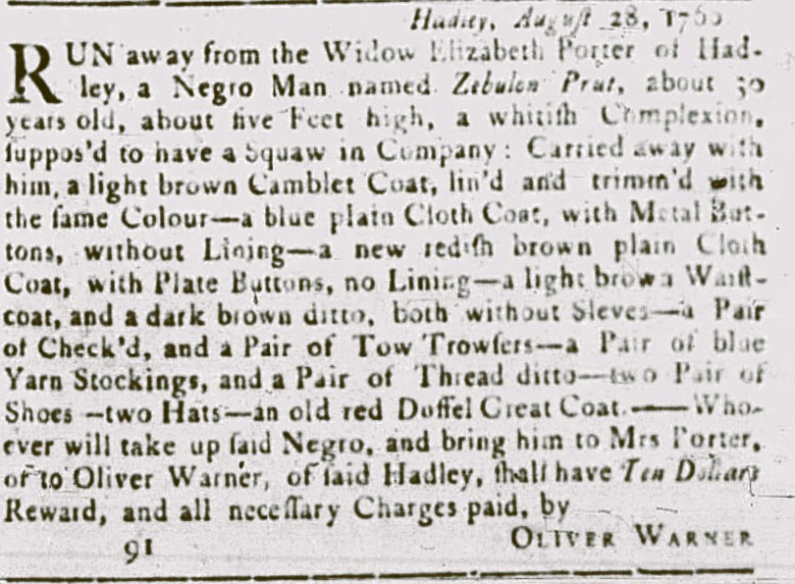
Next, although Zebulon was still at large, Elizabeth Porter sold him to Oliver Warner. He eventually returned voluntarily and remained a slave until the practice was abolished in Massachusetts in 1783. Zebulon died on 2 December 1802. Although there is an exact date of death, there is no Amherst death record and no burial information.
Chloe, b. around 20 July 1738.
Diane Cameron wrote about “Clo” Prutt in her 2005 paper “Circumstances of Their Lives: Enslaved and Free Women of Color, Wethersfield Connecticut 1648 – 1832.” Enslaved from birth, she was freed by the terms of the 1773 will of Katherine Chauncey Russell, another sister of Richard Chauncey.
“Calling to mind the mortality of my body and knowing that it is appointed for all persons once to die and being of sound mind and memory, blessed be God therefore, I do make and ordain this my last will and testament. First of all after my decease my will is that my Negro woman named Chloe Prutt shall then be free. And have her time and also I give to her the bed that she lieth on and furniture belonging to it, and a loom that she weaveth on and tackling, and a porridge pot. one old chest with one draw, one puter pint pot, one knife and fork and a plate and one puter platter and one quart bason one trammel pail and tongs and two old chairs one pail one small square table, one large trunk and several books that are called her own, a small brass skillet and my everyday wearing apparel and red short cloak and two spoons. The remainder of my estate I leave for further consideration, confirming this to be my last will in witness whereof I have signed sealed and declared this to be my last will in the presence of _____ and dated at Wethersfield the 7th day of June anno domini 1773.”
Katherine Chauncey Russell lived for four years after writing her will and Chloe was about 39 when she was freed. She had not only her freedom but essential items for her comfort and occupation: a bed, a loom, some furniture and household items, some books and the wearing apparel of her former mistress.
There was no census until 1790, but as a woman Chloe would have been enumerated only in the column titled “all other persons except Indians.” Two of the men claiming “all other persons” were Simeon and Jacob Robbins, sons of the John Robbins who signed Elizabeth Russell’s will. It is possible that Chloe lived with one of them until 1796 when she purchased a house of her own. In that year Chloe and a friend, another formerly enslaved woman named Doras Hager, purchased a house on Back Lane in Wethersfield. In April 1810, Chloe died of dropsy. The age given was 71.
* * *
We have found documentary evidence of only one other person besides George Prutt who was probably enslaved in Whately, a man who, like Chloe Prutt, was enumerated in 1790 in the column for “all other persons except Indians.” Although slavery was abolished in Massachusetts in 1783, those enslaved at the time were not immediately freed. Many remained in the households of their former slaveholders, working without pay in exchange for room, board, and some degree of care. Given what we now know about the prevalence of slavery in western Massachusetts in the 18th century, however, we can reasonably presume that there were others, and hope to be able to document and remember their lives, as well.
Note: The website African Americans in the Record (https://aane.deerfield-ma.org/sources/source/75/), created in 2023 and maintained by the Pocumtuck Valley Memorial Association, is an excellent resource for original sources in and around Deerfield, Massachusetts.

As the births of the seven Prutt children are not recorded in formal town records, we have included birthdates as they appear in various informal accounts, most of which were written in the late 19th or early 20th centuries.
Pocumtuck Valley Memorial Association Library, Deerfield, MA.
Carpenter & Morehouse, The History of the Town of Amherst, Massachusetts, 1731-1896, 1896.
The History of the Black Population of Amherst, Massachusetts, 1728-1870, New England Historical Genealogical Society, 1999.
Alice Morehouse Walker, A Story of the Making of a Famous Massachusetts Town, NY: Grafton Press, 1906.

