**Perspective on the Past: Whately’s Trolley – 1903 to 1924**

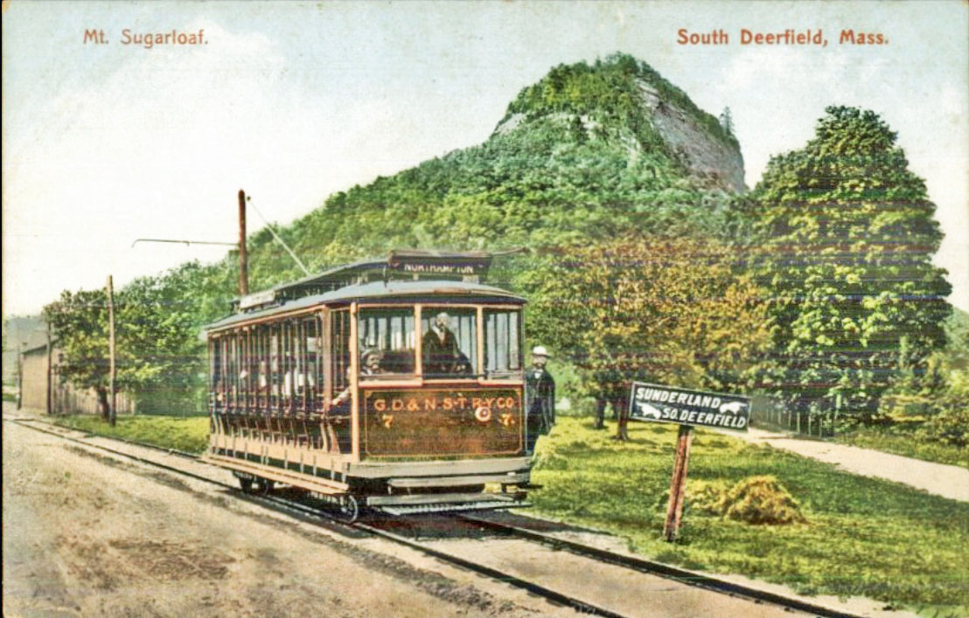Were you aware that a trolley once ran through Whately? It came as a surprise to me, but it’s true. The Historical Society has this wonderful 1910 postcard in its collection, showing a trolley at the intersection of River Road and Sugarloaf Street Extension.

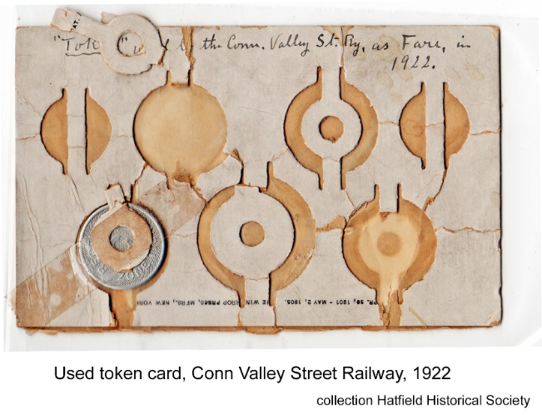Although trains had run through Whately since 1846, it wasn’t until 1901 that local financiers began organizing an electric street railway company. There was great disagreement within Whately about the route the trolley should take through town. Those in Whately Center and W. Whately preferred Chestnut Plain Road. Those in E. Whately – and most importantly the financiers – preferred the cheaper River Road route. In 1902, Whately voters agreed to support this route as long as a spur line was built within two years to Whately Center. The lawyers for the newly organized Greenfield-Northampton Street Railway appealed to the Franklin County Board of Commissioners to approve the franchise without the spur line and were successful. When Whately still refused to join the franchise, the firm appealed to the Board of Electric Railroads in Boston and was granted the franchise in October 1902, over Whately’s objections. In March of 1903 the first trolleys ran through Whately.

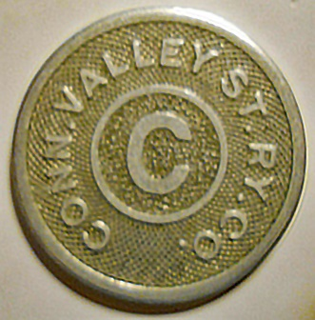

CSVR trolley token, HS Collection

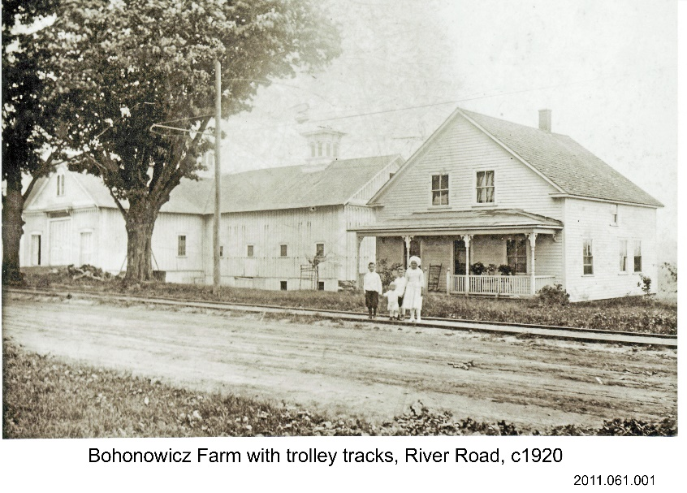 This 1920 photo of the Bohonowicz Farm on the east side of River Road, which was across from what is today Pasciecznik’s, shows the trolley tracks.

By 1905 the streetcar company had become the Connecticut Valley Street Railway, with service running from Hartford up to Greenfield along the Connecticut River. However, most in Whately were content to ride for shorter distances to go shopping or to the theater or movies. (The trolley went straight to the Academy of Music in Northampton, where cars for Amherst, Williamsburg, Easthampton and Holyoke awaited.) There was less soot than on the railroad and the ride was pleasant and cool in the summer. The streetcar line promoted tourism and publicized stops at Laurel Park and Mount Tom. Whately folks rode to the base of Sugarloaf on Saturday nights to go to dances at the pavilion near the trolley stop.

As soon as 1912, the automobile began cutting into the line’s profitability, but the trolley continued to run until March 1924.

By Judy Markland, Whately, MA

May 2022

Sources:

Ena Cane, *Whately Massachusetts, 1771-1971*.

https://en.wikipedia.org/wiki/Connecticut_Valley_Street_Railway

Connecticut Valley Street Transit Route brochure “Take the Trolley”, 1905.